The Steel Industry Profile

Introduction

The steel industry is critical to the U.S. economy. Steel is the material of choice for many elements of construction, transportation, manufacturing, and a variety of consumer products. It is the backbone of bridges, skyscrapers, railroads, automobiles, and appliances. Most grades of steel used today – particularly high-strength steels that are lighter and more versatile – were not available a decade ago.

The U.S. steel industry (including iron production) relies significantly on natural gas and coal coke and breeze for fuel, and is one of the largest energy consumers in the manufacturing sector. The industry accounts for roughly six percent of the total energy consumed in manufacturing (Figure 1). Including fuel and feedstock use, this industry is responsible for approximately 62 percent of the total energy consumed in the primary metals sub-sector.

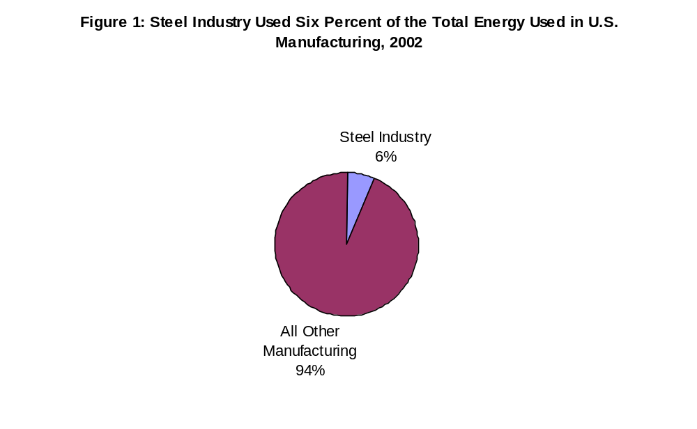
Source: Energy Information Administration, Manufacturing Energy Consumption Survey - Table 1.2: First Use of Energy for All Purposes (Fuel and Nonfuel), 2002, http://www.eia.doe.gov/emeu/mecs/mecs2002/data02/shelltables.html

Energy use in the steel industry has been declining. A ten year historical trend (1991-2002) of the steel industry indicates that there has been a 22 percent decline in the total energy consumption used in the industry (Figure 2). The largest portion, 17 percent of the decline in the total energy consumption occurred between 1998 and 2002.

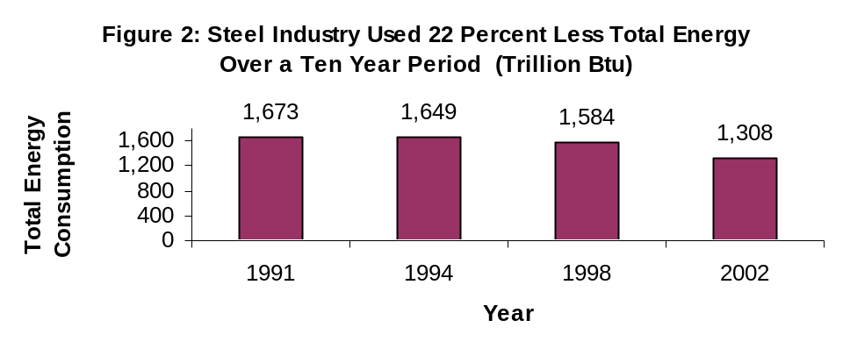
Sources: Energy Information Administration, Manufacturing Energy Consumption Survey - Table 1.2: First Use of Energy for All Purposes (Fuel and Nonfuel), 1991, 1994, 1998, and 2002, http://www.eia.doe.gov/emeu/mecs/mecs2002/data02/shelltables.html

As will be seen later, the drop in total energy consumption coincides with both a decrease in producer price and production indices according to the Federal Reserve Board (FRB) and the U.S. Bureau of Economic Analysis (BEA). Also, the decline in consumption corresponds with a decrease in energy intensity in the industry.

Energy Consumption

There are two types of energy use in the manufacturing sector; energy consumed for fuel and energy consumed for feedstock. Energy consumed as a fuel includes all energy used for heat, power, and electricity generation, regardless of where the energy was produced. Net electricity is included in the energy consumed as a fuel. However, net electricity does not include electricity from onsite generation or combustible fuel sources.

Energy used as a feedstock, sometimes referred to as nonfuel, is the energy used as a raw material for purposes other than for heat, power, and electricity generation. For instance, in the steel industry coal is used as a raw material to produce coal coke.

Energy Consumed as a Fuel - The steel industry used over 1.2 quadrillion Btu (quads) of energy as fuel in 2002. Nearly all of the industry’s fuel consumption came from one of four energy sources: coke and breeze, natural gas, “other”, and electricity (Figure 3). The “other” fuel constitutes two major byproduct fuels – coke oven and blast furnace gases. These two byproduct fuels account for about 95 percent of the “other” fuel used in the industry. They are recovered and used to generate steam, preheat blast furnace air, or supply heat to other plant processes.

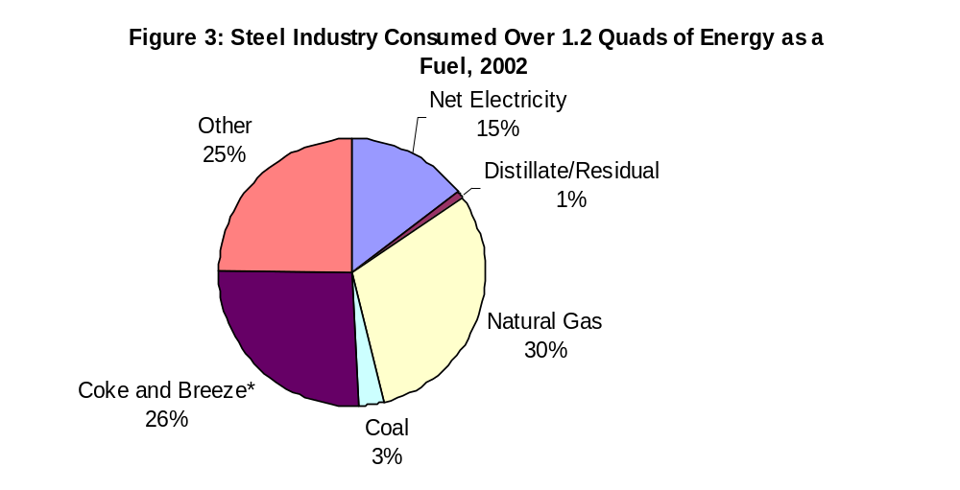
* An adjustment was made to the coke and breeze fuel consumption estimate to account for duplication in fuel use of coke and blast furnace gas. Further explanation about this duplication may be found on the MECS methodology page: http://www.eia.doe.gov/emeu/mecs/mecs2002/methodology_02/meth_02.html#duplication
Sources: Energy Information Administration, Manufacturing Energy Consumption Survey - Table 3.2: Fuel Consumption, Table 3.5: Byproducts in Fuel Consumption, 2002, http://www.eia.doe.gov/emeu/mecs/mecs2002/data02/shelltables.html

Two of the four major energy sources consumed as a fuel in the steel industry – natural gas and byproduct fuel – show a similar declining historical trend, for the same time period, as the total energy consumed for this industry. However, the consumption of coke and breeze and electricity increased during this ten year cycle. Particularly, the coke and breeze consumption increased from 1991 to 1994, whereas the electricity consumption increased from 1998 to 2002 (Figure 4).

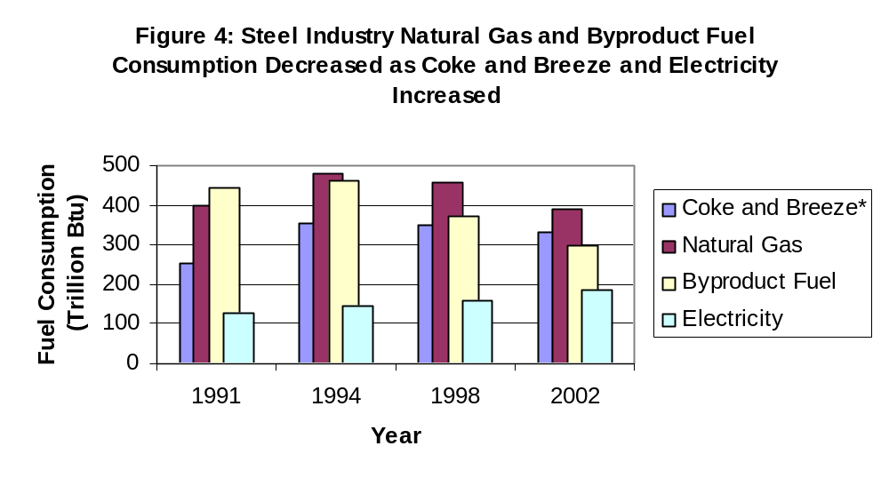
* An adjustment was made to the coke and breeze fuel consumption estimate to account for duplication in fuel use of coke and blast furnace gas. Further explanation about this duplication may be found on the MECS methodology page: http://www.eia.doe.gov/emeu/mecs/mecs2002/methodology_02/meth_02.html#duplication
Sources: Energy Information Administration, Manufacturing Energy Consumption Survey - Table 3.2: Fuel Consumption, Table 3.5: Byproducts in Fuel Consumption, 1991, 1994, 1998, and 2002, http://www.eia.doe.gov/emeu/mecs/mecs2002/data02/shelltables.html

End Use of Fuel Consumption - The Manufacturing Energy Consumption Survey (MECS) collects fuel consumption by end use for six major energy sources – electricity, natural gas, coal, LPG, diesel/distillate, and residual fuel oil. Coke, an energy source used for fuel in a blast furnace, is not included as one of the six major energy sources when collecting for end use in the MECS. A blast furnace is used to turn iron ore into pig iron, an intermediate material used in the production of iron and steel.

Figure 5 illustrates that this industry uses approximately 30 percent of its fuel consumption for process heating, although that percentage does not include the coke that is used to fuel the blast furnace. Though the MECS does not collect end uses for coke, the bulk of what is shown as “not reported/not asked” in Figure 5 is the coke used to fuel the blast furnace. The use of the blast furnace by this industry accounts for the vast majority of the process heating.

There has been little change to the various end uses reported in the manufacturing sector between 1998 and 2002. Figure 5 illustrates a similar pattern in the steel industry during the same time period.

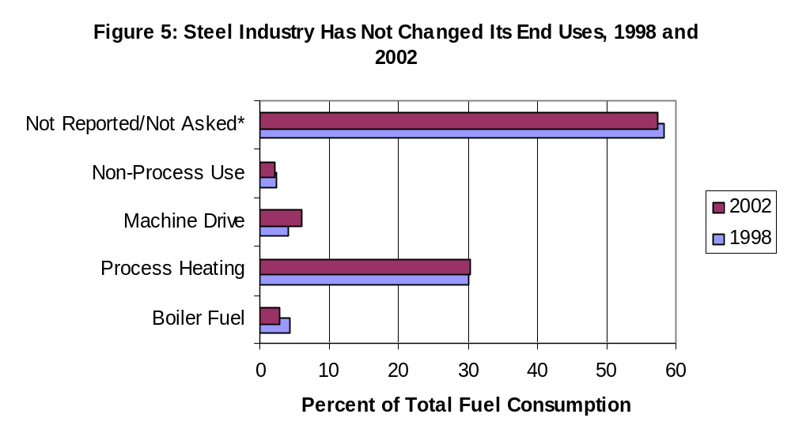
* Not Reported/Not Asked includes end use that was not collected along with those establishments that did not know or report their end use.
Sources: Energy Information Administration, Manufacturing Energy Consumption Survey - Table 5.2: End Uses of Fuel Consumption, 1998, and 2002, http://www.eia.doe.gov/emeu/mecs/mecs2002/data02/shelltables.html

Energy Used as a Feedstock - The steel industry used slightly over half a quad (502 trillion Btu) for feedstock use in 2002. This accounts for approximately six percent of the energy used as a feedstock in the manufacturing sector (Figure 6).

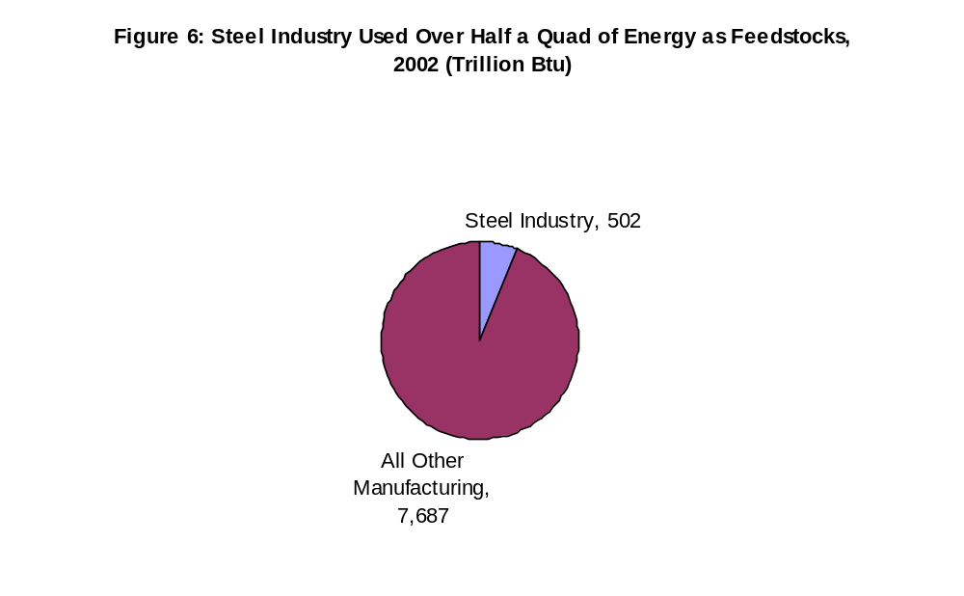
Source: Energy Information Administration, Manufacturing Energy Consumption Survey - Table 2.2: Nonfuel (Feedstock) Use of Combustible Energy, 2002, http://www.eia.doe.gov/emeu/mecs/mecs2002/data02/shelltables.html

The major energy source that is used as a feedstock in the steel industry is coal, and accounts for 92 percent of the total feedstock used in this industry. Coal is baked in a heated oven to produce coke and breeze. This process allows for the impurities of the coal to be burned off while not allowing the carbon content of the coal to burn. Coke and breeze are used for two purposes: to fuel the blast furnace, and to deoxygenate the iron ore and turn it into wrought iron. It’s the addition of limestone to the blast furnace along with the heat from the coke and breeze that turns the wrought iron into pig iron.
Coal used as a feedstock in this industry accounts for roughly 60 percent of the coal feedstock used in the manufacturing sector (Figure 7), and 99 percent of the coal feedstock used in the primary metals sub-sector.

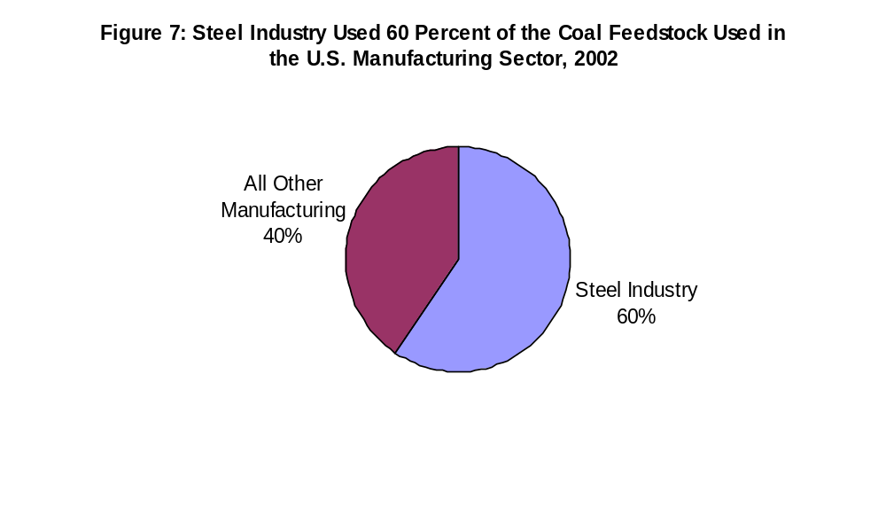
Source: Energy Information Administration, Manufacturing Energy Consumption Survey - Table 2.2: Nonfuel (Feedstock) Use of Combustible Energy, 2002, http://www.eia.doe.gov/emeu/mecs/mecs2002/data02/shelltables.html

Energy Expenditures

The total energy expenditures in the steel industry were over six billion dollars in 2002, 97 percent coming from electricity, natural gas, coke and breeze, and coal (Figure 8). Electricity is the largest expenditure and accounts for approximately 32 percent of the total energy expenditures in this industry.

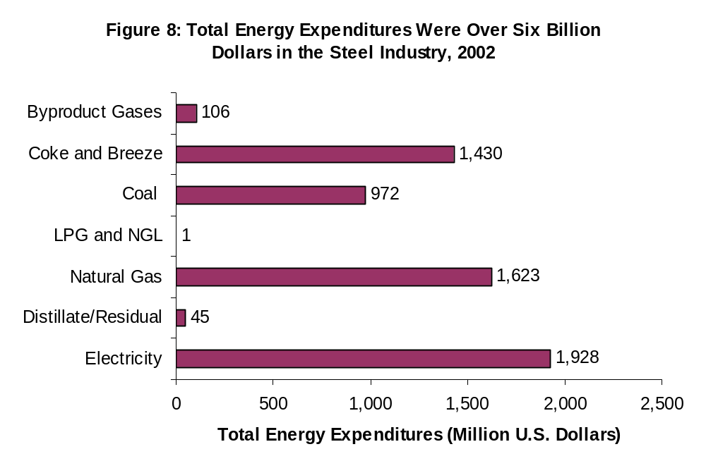
Source: Energy Information Administration, Manufacturing Energy Consumption Survey - Table 7.9: Expenditures for Purchased Energy Sources, 2002, http://www.eia.doe.gov/emeu/mecs/mecs2002/data02/shelltables.html

The electricity expenditures increased by 70 million dollars between 1998 and 2002 in this industry. At least partially, electricity accounts for such a large share of expenditures because electric-arc furnaces, more efficient in producing iron and steel, have become more common in the industry. Table 1 illustrates the evolution of iron and steel mills transitioning away from using blast furnaces to electric-arc furnaces between 1997 and 2002.

Table 1: Plight of the Blast Furnace in Iron and Steel Mills, 1997 and 2002
 | 1997 | 2002 | 1997 Percent of Total | 2002 Percent of Total
Number of Establishments with Blast Furnaces | 21 | 9 | 7.5 | 2.4
Number of Establishments without Blast Furnaces | 258 | 364 | 92.5 | 97.6
Value of Shipments with Blast Furnaces (Million U.S. Dollars) | 29,086 | 12,451 | 51.0 | 26.4
Value of Shipments without Blast Furnaces (Million U.S. Dollars) | 27,983 | 34,720 | 49.0 | 73.6
Purchased Electricity with Blast Furnaces (Trillion Btu) | 52.8 | 26.2 | 34.6 | 14.1
Purchased Electricity without Blast Furnaces (Trillion Btu) | 100.0 | 158.9 | 65.4 | 85.9
Sources: U.S. Census Bureau, Economic Census – Manufacturing Industry Series, Iron and Steel Mills – Table 3: Detailed Statistics by Industry, 1997, http://www.census.gov/prod/ec97/97m3311a.pdf, and 2002, http://www.census.gov/prod/ec02/ec0231i331111.pdf

Figure 9 shows the historical energy expenditures per the total establishment costs in the steel industry. The percentages do not deviate much between 1991 and 1998; however, there was a sharp increase in the percentage between 1998 and 2002.

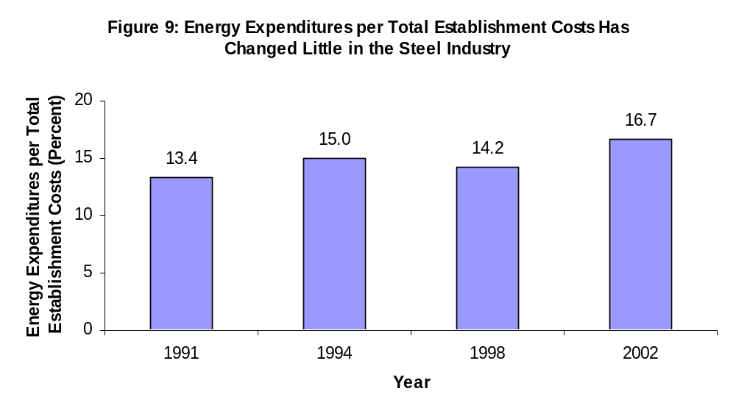
Sources: Energy Information Administration, Manufacturing Energy Consumption Survey – Table 7.9: Expenditures for Purchased Energy Sources, 1991, 1994, 1998, and 2002, http://www.eia.doe.gov/emeu/mecs/mecs2002/data02/shelltables.html; U.S. Census Bureau, 1991, 1994, and 1998 Annual Survey of Manufacturing, 2002 Economic Census – Manufacturing, http://www.census.gov/prod/www/abs/manu-min.html

The average prices for purchased energy in the steel industry did not deviate much except for natural gas. Table 2 illustrates that the average natural gas price increased from $2.54 per million Btu in 1994 to $3.89 per million Btu in 2002. In contrast, the average price for coal and coke increased by only $0.15 and $0.27 per million Btu respectively, and electricity decreased by $0.57 per million Btu during the same time period. The increased price for natural gas could partially explain why there was a reduction in the energy consumption in the steel industry.

Table 2: Steel Energy Prices 1994-2002 (Dollars per Million Btu)
Year | Total | Electricity | Natural Gas | Coal | Coke
2002 | 4.18 | 10.40 | 3.89 | 1.93 | 4.49
1998 | 3.29 | 10.34 | 2.78 | 1.40 | 4.71
1994 | 2.93 | 10.97 | 2.54 | 1.78 | 4.22
Source: Energy Information Administration, Manufacturing Energy Consumption Survey – Table 7.2: Average Prices for Purchased Energy Sources, 1994, 1998, and 2002, http://www.eia.doe.gov/emeu/mecs/mecs2002/data02/shelltables.html

Producer Prices and Production

Table 3 shows the producer price indices for the steel industry according to the U.S. Bureau of Economic Analysis (BEA). Producer prices are the prices that the industry received for their goods. As is shown in Table 3, the indices have declined between 1998 and 2002.

Additionally, Table 4 below illustrates the production indices for the steel industry according to the Federal Reserve Board (FRB) and the BEA. Similar to the producer price indices shown in Table 3, the production indices in Table 4 have also decreased between 1998 and 2002.

The data in Table 3 shows that in 2002 the industry received relatively lower prices for their steel products. In turn, lower prices would tend to lessen their output, as evidenced by the data in Table 4. A decrease in the production of steel products means that there often will be a reduction in the industry’s energy consumption and is supported by the data in Figure 2. As discussed in the next section, energy intensity can also be an explanation for the drop in the industry’s energy consumption.

Table 3: Steel Industry Received Relatively Lower Prices for their Products
Producer Price Indices | 1998 | 1999 | 2000 | 2001 | 2002
BEA | 107.028 | 97.691 | 100 | 93.825 | 97.832
Source: U.S. Bureau of Economic Analysis, Gross-Domestic-Product-(GDP)-by Industry Data, http://bea.gov/industry/gdpbyind_data.htm

Table 4: Steel Industry Reduced Shipments
Production Indices | 1998 | 1999 | 2000 | 2001 | 2002
FRB | 100.280 | 101.003 | 100 | 90.455 | 90.181
BEA | 99.796 | 102.69 | 100 | 90.259 | 92.603
Sources: Federal Reserve Board, G.17: Industrial Production and Capacity Utilization, http://www.federalreserve.gov/releases/g17/; U.S. Bureau of Economic Analysis, Gross-Domestic-Product-(GDP)-by Industry Data, http://bea.gov/industry/gdpbyind_data.htm

Energy Intensity

Typically in dealing with energy statistics, energy intensities are measured as a ratio of energy consumption per an economic measure. One such economic measure often used is the dollar value of shipments. This is the dollar value received for the complete output at the company's net billing price, including charges for cooperative advertising and warranties. This does not include excise taxes, freight or transportation charges, or installation charges.

Another economic measure that is commonly used when analyzing energy intensities is the dollar of value added. This is a measure of manufacturing activity that is derived by subtracting the cost of materials (which covers materials, supplies, containers, fuel, purchased electricity, and contract work) from the value of shipments. This difference is then adjusted by the net change in finished goods and work-in-progress between the beginning- and end-of-year inventories.

By either means, the energy intensity has declined over the past ten years. The energy consumption per dollar value of shipments has steadily decreased for this industry (Figure 10) as has the energy consumption per dollar of value added (Figure 11). Decreases in these energy intensities can be an indication that the energy efficiency in the industry has improved.

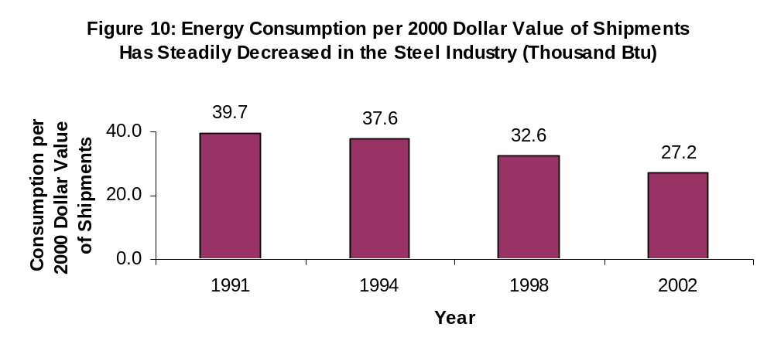
Sources: Energy Information Administration, Manufacturing Energy Consumption Survey – Table 6.1: Consumption Ratios of Fuel, 1991, 1994, 1998, and 2002, http://www.eia.doe.gov/emeu/mecs/mecs2002/data02/shelltables.html; U.S. Bureau of Economic Analysis, Gross-Domestic-Product-(GDP)-by Industry Data, 1991, 1994, 1998, and 2002, http://bea.gov/industry/gdpbyind_data.htm

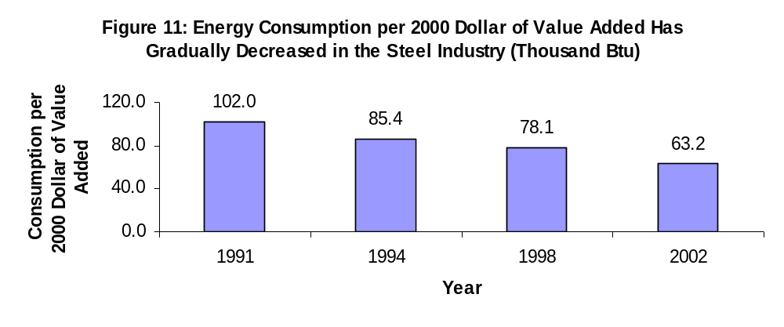
Note: Value added price indices from Bureau of Economic Analysis are for the primary metals sub-sector.
Sources: Energy Information Administration, Manufacturing Energy Consumption Survey – Table 6.1: Consumption Ratios of Fuel, 1991, 1994, 1998, and 2002, http://www.eia.doe.gov/emeu/mecs/mecs2002/data02/shelltables.html; U.S. Bureau of Economic Analysis, Gross-Domestic-Product-(GDP)-by Industry Data, 1991, 1994, 1998, and 2002, http://bea.gov/industry/gdpbyind_data.htm

Energy-Management Activities

Over the past several years manufacturers in general have increasingly recognized the correlation between rising energy costs and their ever shrinking profit margins. Through this understanding, manufacturers have greatly improved their energy-management practices. Although Table 5 suggests that the steel industry has not followed this trend the majority of the data represented in the table is not statistically significant.

Special rate schedules are natural gas and electricity contracts that utility companies sell to their industrial customers at a reduced rate because of the sheer volume of energy usage. Although this industry started using more electric-arc furnaces to produce steel, their participation percent for special rate schedules decreased from 1998 to 2002. This decrease occurred during a time when the deregulation of both the natural gas and electricity markets were becoming more prevalent, and industrial customers started purchasing their energy from third party suppliers. The industry also stopped using as many full-time energy managers; however, this reduction may be a result of the employees having more than just energy-management responsibilities.

Table 5: Steel Industry Participated in Energy-Management Activities, 1998 and 2002
Energy-Management Activity | Percent Participation in 1998 | Percent Participation in 2002 | Percent Change 1998-2002
Energy Audits | 26 | 37 | -11
Direct Electricity Load Control | 41 | 28 | 13
Special Rate Schedule | 57 | 15 | 41*
Standby Generation Program | 14 | 7 | 6*
Equipment Rebates | 4 | 4 | 0
Power Factor Correction or Improvement | 31 | 28 | 3
U.S. Environmental Protection Agency's Green Lights Program | 4 | 2 | 2*
Equipment Installation or Retrofit for the Primary Purpose of Improving Energy Efficiency Affecting:
Steam Production/System | 14 | 22 | -8
Compressed Air Systems | 23 | 14 | 9
Direct/Indirect Process Heating | 19 | 17 | 2
Direct Process Cooling, Refrigeration | 7 | 6 | 1
Direct Machine Drive | 29 | 26 | 3
Facility HVAC | 19 | 19 | 0
Facility Lighting | 17 | 19 | -2
Equipment Installation or Retrofit for the Primary Purpose of Using a Different Energy Source | 11 | 6 | 5
Full-Time Energy Manager | 17 | 2 | 15*
* Significance testing was performed on the percentages in Table 5 to account for relative standard errors during data collection and determine those differences that are truly significant.
Sources: Energy Information Administration, Manufacturing Energy Consumption Survey – Table 8.1: Number of Establishments by Participation in Energy-Management Activity, 1998, and 2002, http://www.eia.doe.gov/emeu/mecs/mecs2002/data02/shelltables.html

The percent participation rates were also measured for the same energy-management activities for all manufacturing industries in the U.S. economy. Those results showed that the percent of manufacturing establishments participating in the energy-management activities increased from 1998 to 2002. Although the steel industry improved their percent participation in a couple of the energy-management activities, for the most part, their participation in energy-management activities decreased between 1998 and 2002. This does not mean necessarily that the participation in energy-management activities is decreasing in the steel industry. It is possible that the iron and steel manufacturers are utilizing industry-specific energy-efficient activities that might have caused lower energy intensity. However, the MECS, more generally focused, did not ask about those activities because of the difficulty of capturing all of the energy-management activities employed throughout the U.S. manufacturing sector.

Fuel Switching Capability

The capability to switch from one energy source to another has many benefits for steel manufacturers. For instance, a steel mill can save money by switching from one fuel to another when energy prices rise. However, there are limitations to fuel switching as well. One limitation is that a mill might not be able to switch to another energy source because one is not readily available, or may adversely change the composition of the product. Such is the case in a steel mill where coal coke is used in a blast furnace to produce pig iron.

Table 6 depicts the fuel switching capability in the steel industry in 2002. It does not measure whether this industry did switch, but rather, has the capability to switch to an alternate fuel within 30 days. The table shows that this industry has a limited amount of fuel switching capability.

Table 6: Steel Industry Has Limited Capability to Switch Fuels, 2002 (Billion Btu)
Capability to Switch from: | Total Consumed* | Amount Switchable | Percent of Total Consumed
Natural Gas | 387,179 | 46,215 | 12
Residual Fuel Oil | 604 | 0 | 0
Electricity | 185,463 | 3,173 | 2
Distillate Fuel Oil | 10,293 | Q | N/A
Coal | 38,501 | 1,237 | 3
LPG | 130 | 4 | 3
* The total electricity consumed amount does not include any electricity generated onsite.
Q = Withheld because Relative Standard Error is greater than 50 percent.
Sources: Energy Information Administration, Manufacturing Energy Consumption Survey – Tables 10.2, 10.4, 10.6, 10.8, 10.10, and 10.12: Capability to Switch Fuels to Alternative Energy Sources, 2002, http://www.eia.doe.gov/emeu/mecs/mecs2002/data02/shelltables.html

U.S. Department of Energy, Energy Efficiency and Renewable Energy, Industrial Technologies Program, Steel Industry of the Future, http://www1.eere.energy.gov/industry/steel/profile.html
Energy Information Administration, Manufacturing Energy Consumption Survey, MECS Definition of Fuel Use, http://www.eia.doe.gov/emeu/mecs/mecs98/datatables/fueldef.html
Energy Information Administration, Manufacturing Energy Consumption Survey, MECS Definition of NonFuel (Feedstock), http://www.eia.doe.gov/emeu/mecs/mecs98/datatables/nonfueldef.html
American Iron and Steel Institute, Coke Production for Blast Furnace Ironmaking, http://www.steel.org/AM/Template.cfm?Section=Articles3&TEMPLATE=/CM/ContentDisplay.cfm&CONTENTID=12304
Energy Information Administration Glossary, http://www.eia.doe.gov/glossary/glossary_v.htm
Energy Information Administration Glossary, http://www.eia.doe.gov/glossary/glossary_v.htm

